**DAILY ONLINE ACTIVITIES SUMMARY**

|  |  |  |  |
| --- | --- | --- | --- |
| **Date:** | 5/07/2020 | **Name:** | Krishnitha |
| **Sem & Sec** | 4th sem, A Section | **USN:** | 4AL18CS039 |
| **Online Test Summary** | | | |
| **Subject** | NA | | |
| **Max. Marks** | NA | **Score** | NA |
| **Certification Course Summary** | | | |
| **Course** | Cloud Support Associate | | |
| **Certificate Provider** | AWS Educate | **Duration:** | 4 hrs |
| **Coding Challenges** | | | |
| **Problem Statement:**  Given an array **arr[]** of integers and an integer **K**, the task is to print all subsets of the given array with the sum equal to the given target K. | | | |
| **Status:** Executed | | | |
| **Uploaded the report in GitHub** | | YES | |
| **If yes Repository name** | | <https://github.com/krishnitha/C-coding> | |
| **Uploaded the report in slack** | | YES | |

**Certification Course Details:**

Today I have continued the course “Cloud Support Associate” by AWS Educate. In this course today I learnt about ‘Software Development’ and ‘Data and Databases’. I completed assessment of these modules and also completed the final assessment and final project. I have received a Badge for completion of this course.

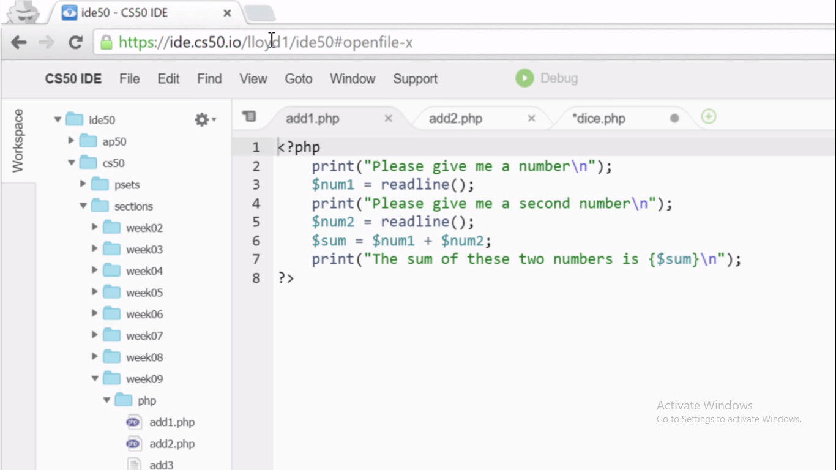

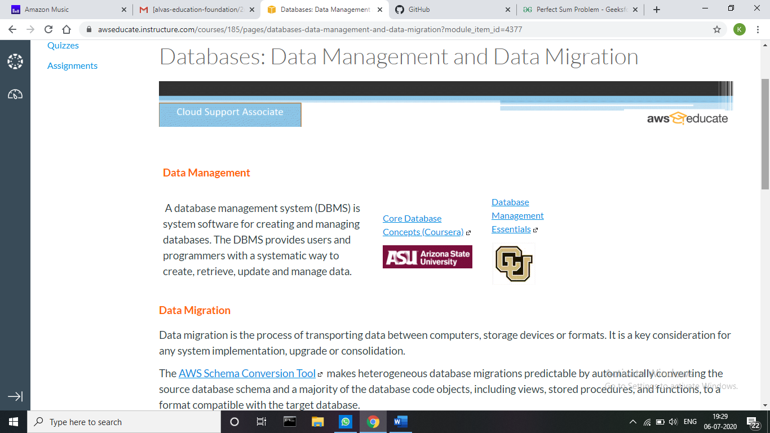



**Coding Challenges Details:**

**Problem:** Given an array **arr[]** of integers and an integer **K**, the task is to print all subsets of the given array with the sum equal to the given target K.

**Examples:**

**Input:** arr[] = {5, 10, 12, 13, 15, 18}, K = 30

**Output:** {12, 18}, {5, 12, 13}, {5, 10, 15}

**Explanation:** Subsets with sum 30 are: 12 + 18 = 30 5 + 12 + 13 = 30 5 + 10 + 15 = 30

**Input:** arr[] = {1, 2, 3, 4}, K = 5

**Output:** {2, 3}, {1, 4}

**Solution:** Uploaded it in GitHub

